Cone-Based Repeated Composite Solids

Definition
# Source: AI Source: Provided by: [Data Path: Persons Table -> ID Column: 1, Name_En Column: Motasem Essam] -> From: [ChatGPT] on [7/25/2026]
Cone-Based Repeated Composite Solids are three-dimensional geometric structures formed by joining two or more cones in a repeated pattern or arrangement.
The cones may have identical or different base radii, heights, slant heights, and orientations. They can be connected through their circular bases, arranged base-to-base, positioned along a common axis, or combined into more complex configurations.
These composite solids include stacked cones, double-cone structures, coaxial cone arrangements, radial arrangements, symmetrical cone structures, and other repeated configurations.

Simple Definition
# Source: AI Source: Provided by: [Data Path: Persons Table -> ID Column: 1, Name_En Column: Motasem Essam] -> From: [ChatGPT] on [7/25/2026]
A cone-based repeated composite solid is a 3D structure made by joining multiple cones in a repeated arrangement.
For example, two cones joined through their circular bases or several cones arranged around a central point form cone-based repeated composite solids.

Geometric Representation
# Source: AI Source: Provided by: [Data Path: Persons Table -> ID Column: 1, Name_En Column: Motasem Essam] -> From: [ChatGPT] on [7/25/2026]
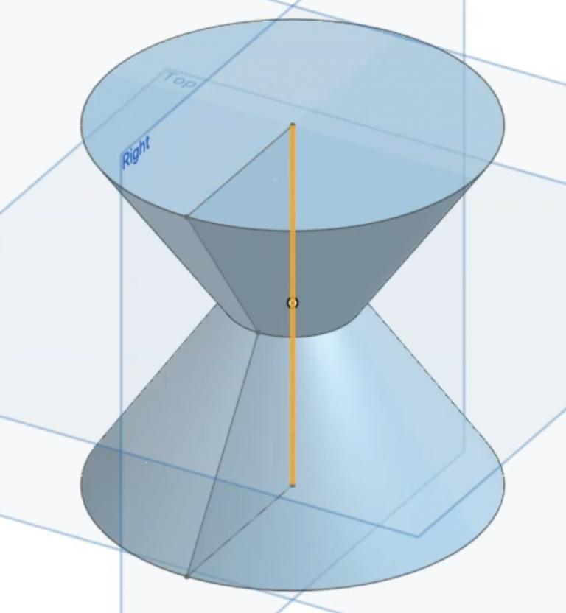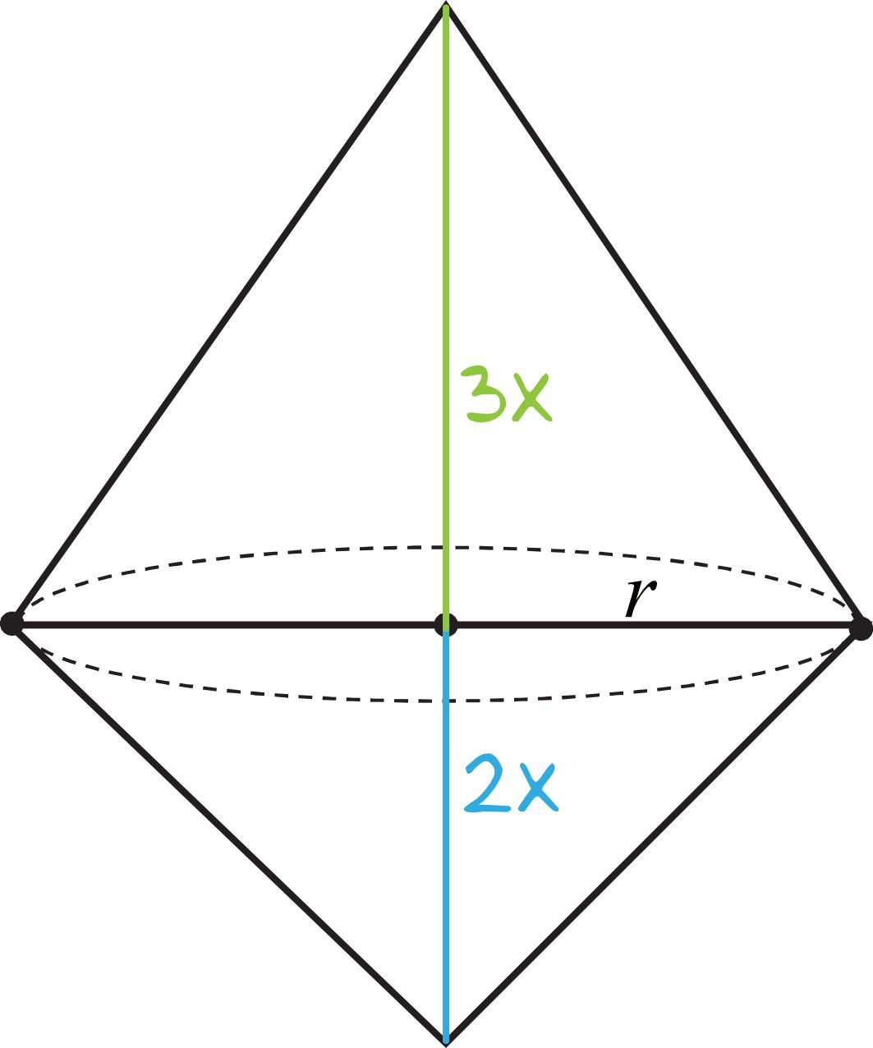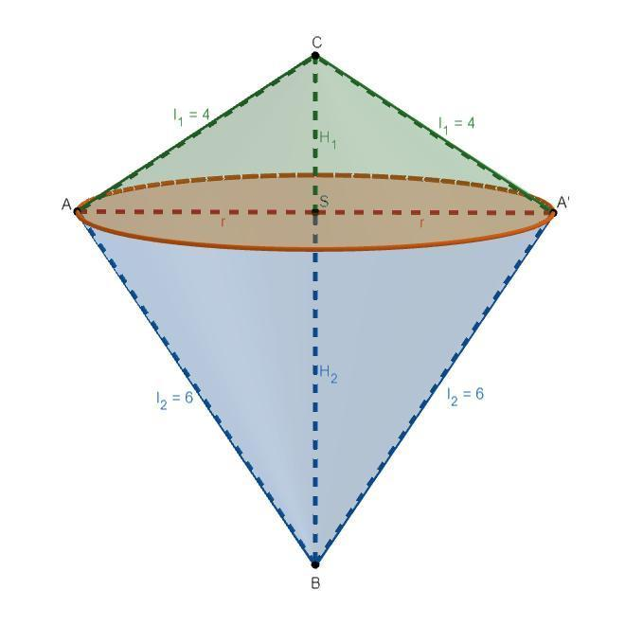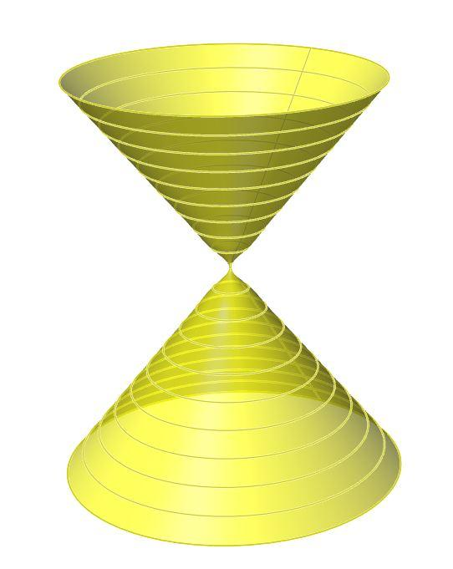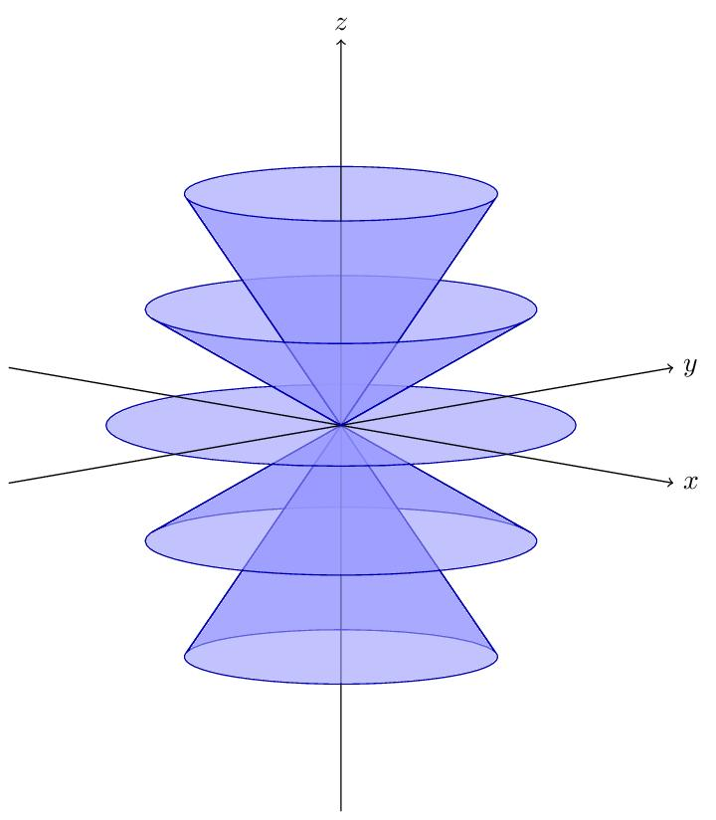
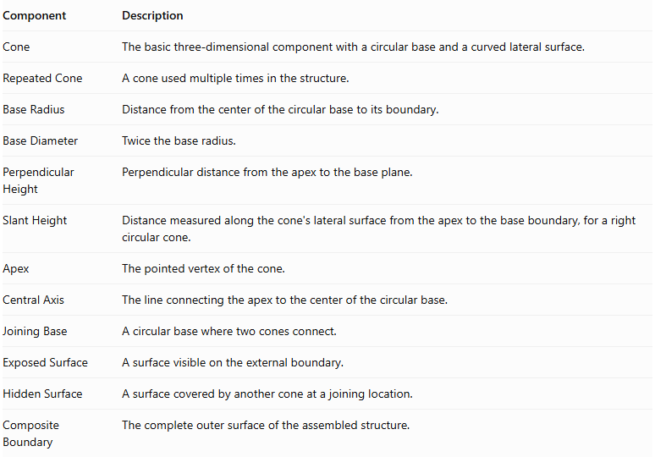
Component | Description
Cone | The basic three-dimensional component with a circular base and a curved lateral surface.
Repeated Cone | A cone used multiple times in the structure.
Base Radius | Distance from the center of the circular base to its boundary.
Base Diameter | Twice the base radius.
Perpendicular Height | Perpendicular distance from the apex to the base plane.
Slant Height | Distance measured along the cone's lateral surface from the apex to the base boundary, for a right circular cone.
Apex | The pointed vertex of the cone.
Central Axis | The line connecting the apex to the center of the circular base.
Joining Base | A circular base where two cones connect.
Exposed Surface | A surface visible on the external boundary.
Hidden Surface | A surface covered by another cone at a joining location.
Composite Boundary | The complete outer surface of the assembled structure.

Types of Cone-Based Repeated Composite Solids

Linear Cone-Based Composite Solids
# Source: AI Source: Provided by: [Data Path: Persons Table -> ID Column: 1, Name_En Column: Motasem Essam] -> From: [ChatGPT] on [7/25/2026]
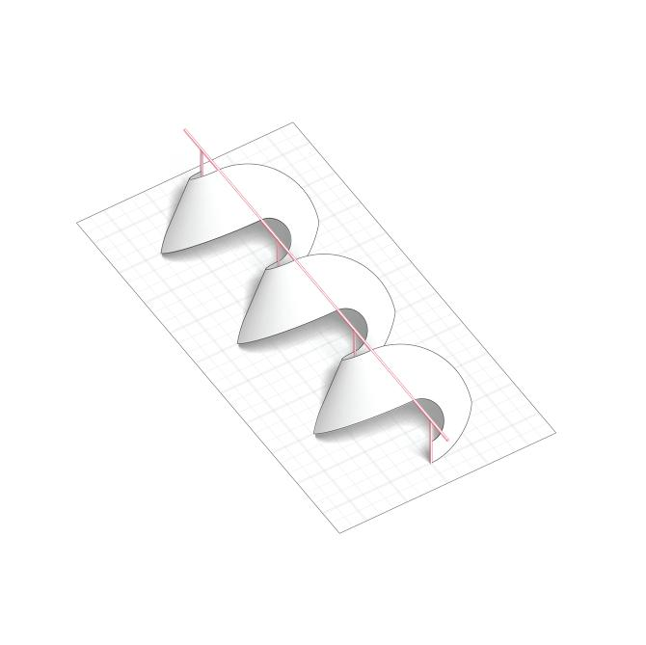
Formed by arranging cones in a straight sequence along one direction.
Types include:
- Horizontal Linear Arrangement.
- Vertical Linear Arrangement.
- Depth-Wise Linear Arrangement.
- Alternating Cone Arrangement.
- Equal-Dimension Linear Arrangement.
- Different-Dimension Linear Arrangement.

Coaxial Cone-Based Composite Solids
# Source: AI Source: Provided by: [Data Path: Persons Table -> ID Column: 1, Name_En Column: Motasem Essam] -> From: [ChatGPT] on [7/25/2026]
Formed by positioning two or more cones along the same central axis.
Types include:
- Equal-Base-Radius Coaxial Arrangement.
- Different-Base-Radius Coaxial Arrangement.
- Equal-Height Coaxial Arrangement.
- Different-Height Coaxial Arrangement.
- Same-Direction Coaxial Arrangement.
- Opposite-Direction Coaxial Arrangement.

Base-to-Base Cone-Based Composite Solids
# Source: AI Source: Provided by: [Data Path: Persons Table -> ID Column: 1, Name_En Column: Motasem Essam] -> From: [ChatGPT] on [7/25/2026]
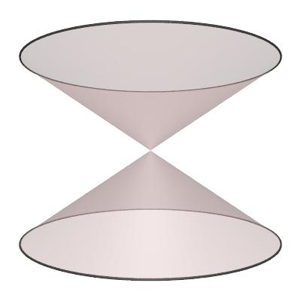
Formed by joining two cones through their circular bases.
Types include:
- Equal-Cone Base-to-Base Arrangement.
- Unequal-Cone Base-to-Base Arrangement.
- Symmetrical Double Cone.
- Asymmetrical Double Cone.
- Multi-Cone Base-to-Base Arrangement.

Apex-to-Apex Cone-Based Composite Solids
# Source: AI Source: Provided by: [Data Path: Persons Table -> ID Column: 1, Name_En Column: Motasem Essam] -> From: [ChatGPT] on [7/25/2026]
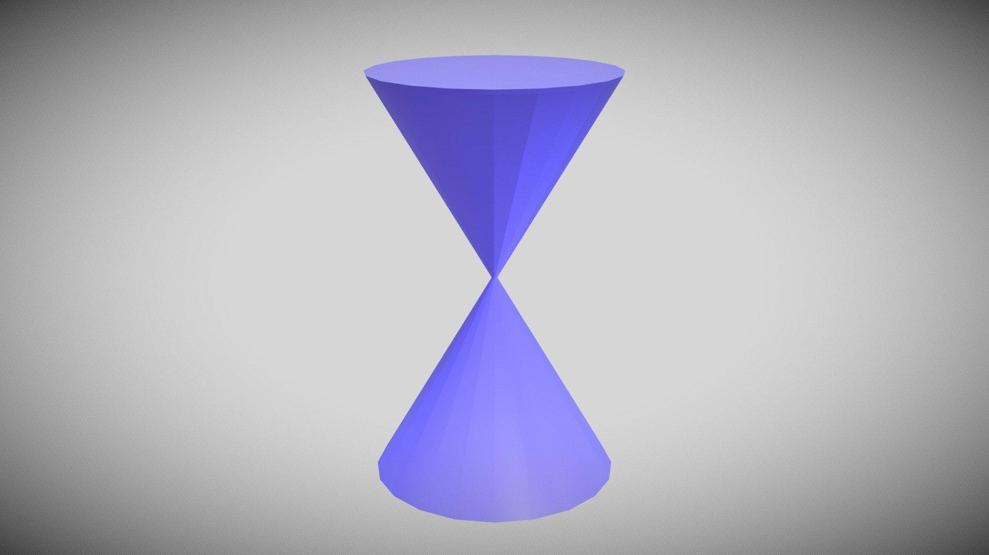
Formed by positioning two cones so that their apexes meet.
Types include:
- Equal-Cone Apex-to-Apex Arrangement.
- Unequal-Cone Apex-to-Apex Arrangement.
- Coaxial Apex-to-Apex Arrangement.
- Symmetrical Apex-to-Apex Arrangement.
- Multiple Apex-Connected Arrangement.
Important: When two cones touch only at their apexes, they have point contact rather than a shared face. This is a touching collection of solids, not a conventional face-connected composite solid.

Stacked Cone-Based Composite Solids
# Source: AI Source: Provided by: [Data Path: Persons Table -> ID Column: 1, Name_En Column: Motasem Essam] -> From: [ChatGPT] on [7/25/2026]
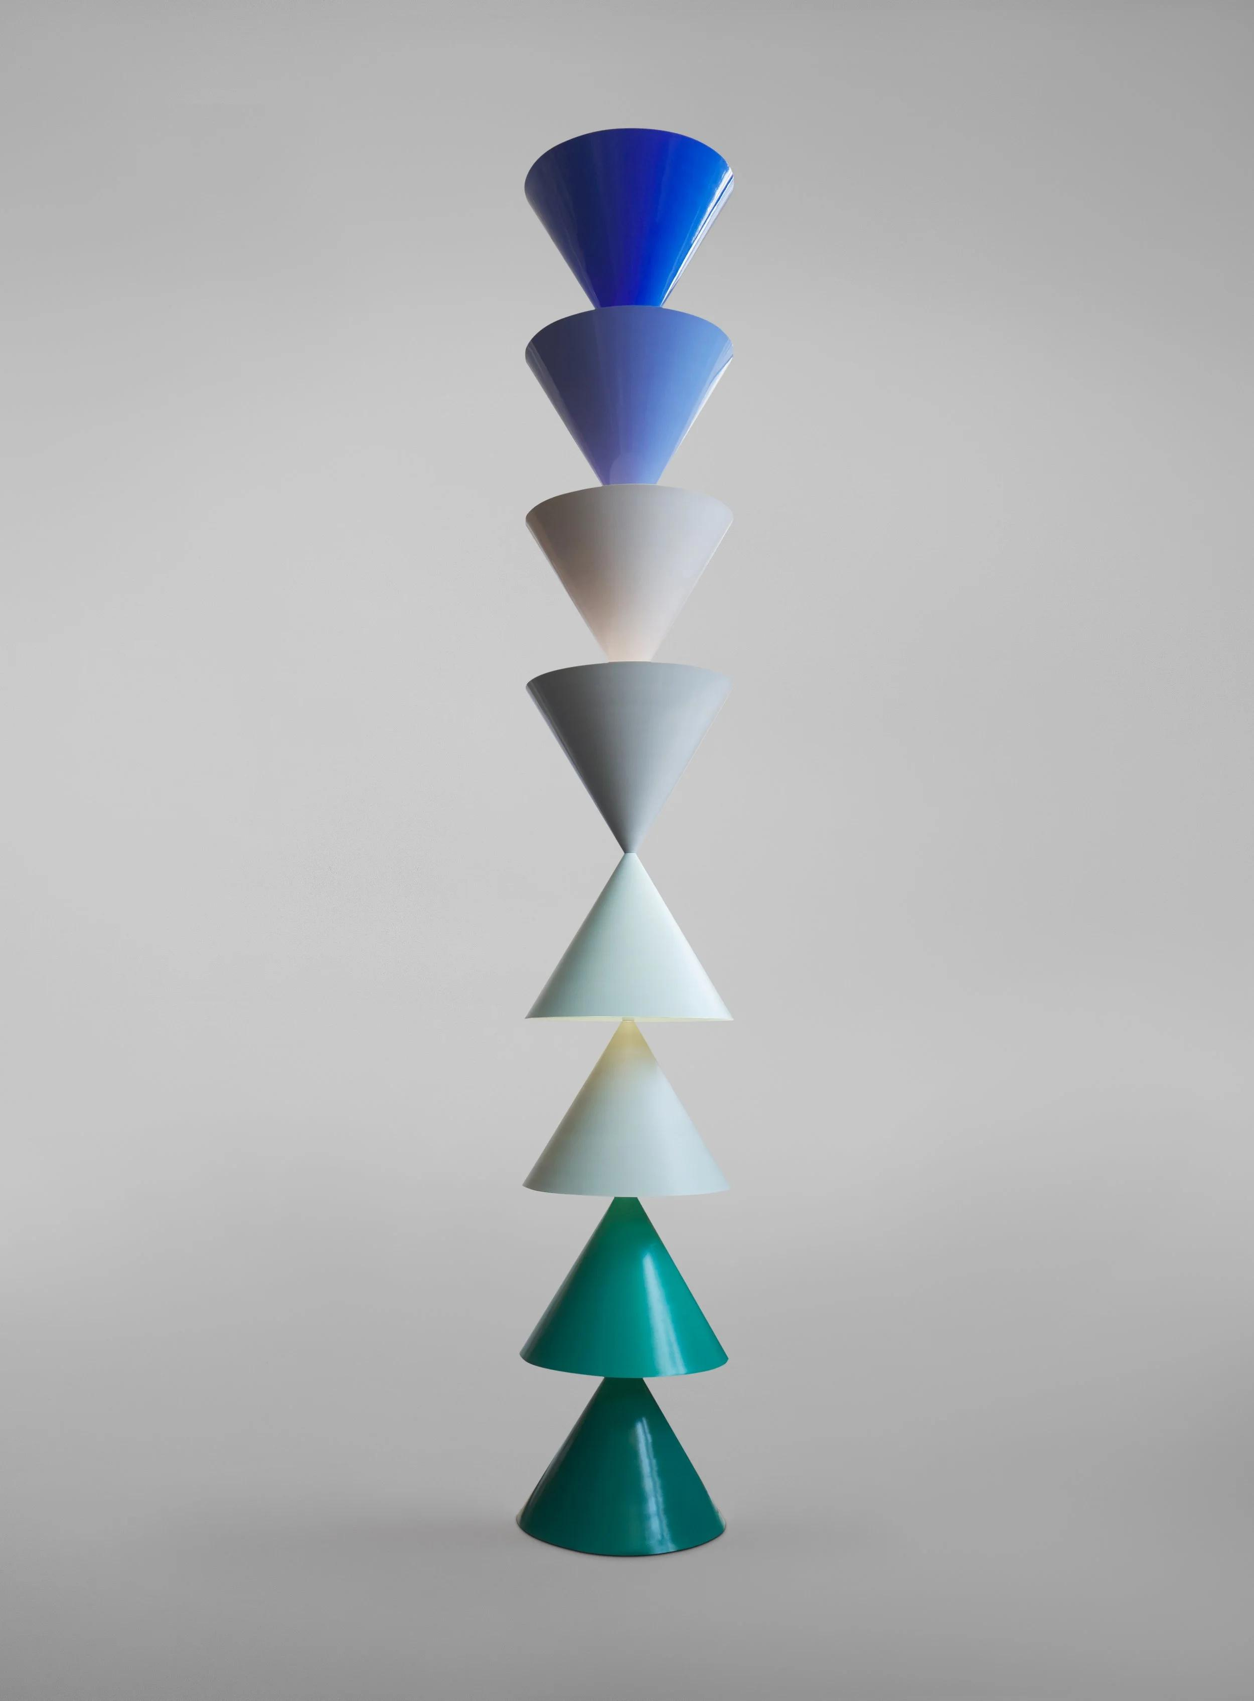
Formed by arranging cones vertically in successive levels.
Types include:
- Equal-Size Stacked Cones.
- Different-Size Stacked Cones.
- Progressively Enlarged Cone Stack.
- Progressively Reduced Cone Stack.
- Alternating Cone Stack.
- Multi-Level Cone Stack.

Radial Cone-Based Composite Solids
# Source: AI Source: Provided by: [Data Path: Persons Table -> ID Column: 1, Name_En Column: Motasem Essam] -> From: [ChatGPT] on [7/25/2026]
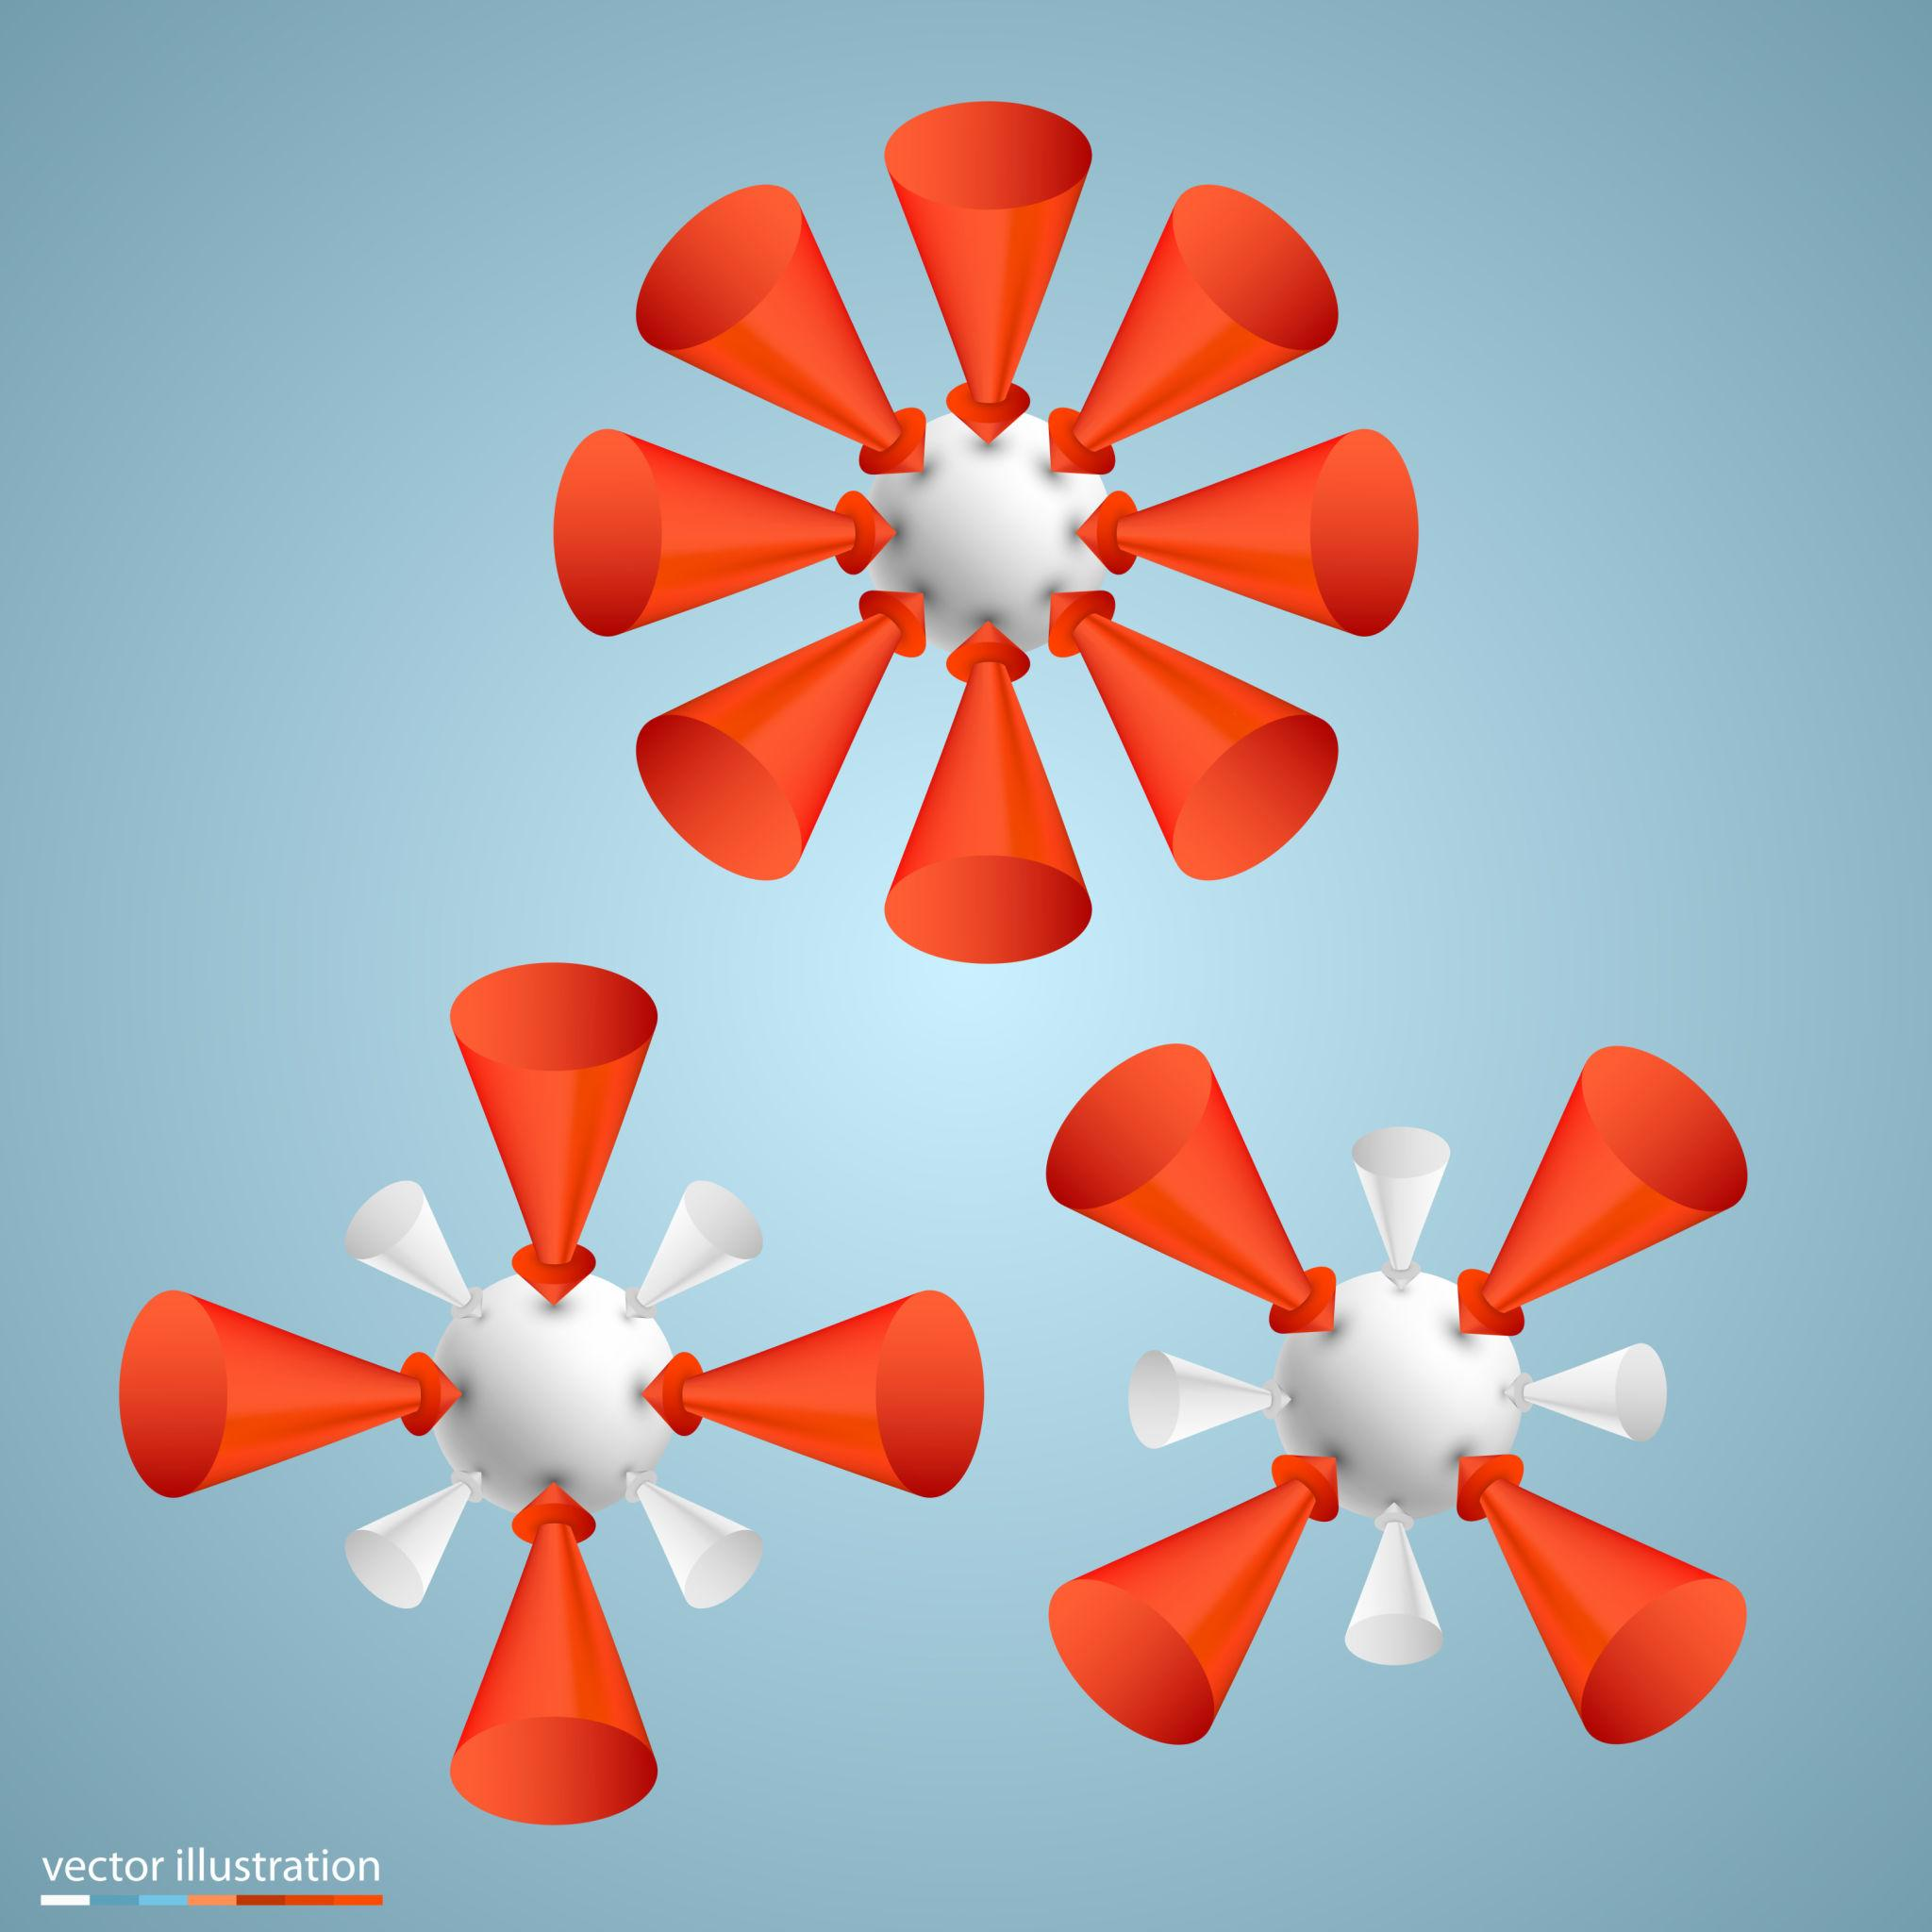
Formed by arranging cones around a central point, axis, or central geometric component.
Types include:
- Two-Direction Radial Arrangement.
- Three-Cone Radial Arrangement.
- Four-Cone Radial Arrangement.
- Circular Radial Arrangement.
- Symmetrical Radial Arrangement.
- Multi-Layer Radial Arrangement.

Side-by-Side Cone-Based Composite Solids
# Source: AI Source: Provided by: [Data Path: Persons Table -> ID Column: 1, Name_En Column: Motasem Essam] -> From: [ChatGPT] on [7/25/2026]
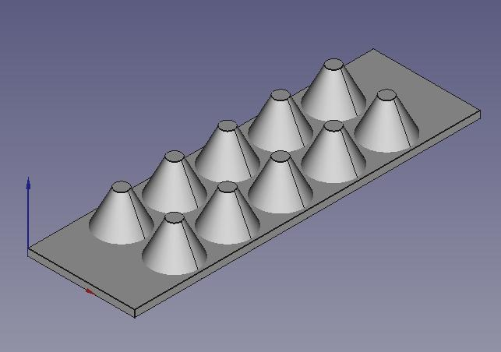
Formed by positioning cones next to one another, usually with parallel central axes.
Types include:
- Two-Cone Side-by-Side Arrangement.
- Row-Based Arrangement.
- Grid-Based Arrangement.
- Parallel Cone Arrangement.
- Equal-Spacing Arrangement.
- Unequal-Spacing Arrangement.
Note: Side-by-side cones may touch along portions of their curved surfaces. The contact region must be considered when determining whether they form one connected solid and calculating external surface area.

Cross-Shaped Cone-Based Composite Solids
# Source: AI Source: Provided by: [Data Path: Persons Table -> ID Column: 1, Name_En Column: Motasem Essam] -> From: [ChatGPT] on [7/25/2026]
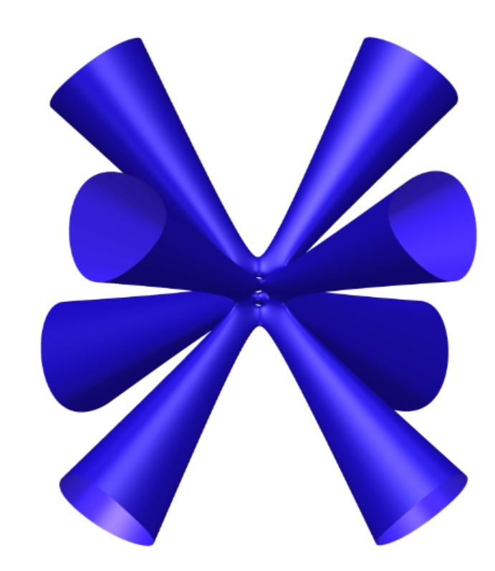
Formed by positioning cones along multiple directions around a central region.
Types include:
- Two-Direction Cross Arrangement.
- Three-Direction Cross Arrangement.
- Four-Arm Cross Arrangement.
- Multi-Arm Cross Arrangement.
- Symmetrical Cross Arrangement.
- Asymmetrical Cross Arrangement.

Hollow Cone-Based Repeated Composite Solids
# Source: AI Source: Provided by: [Data Path: Persons Table -> ID Column: 1, Name_En Column: Motasem Essam] -> From: [ChatGPT] on [7/25/2026]
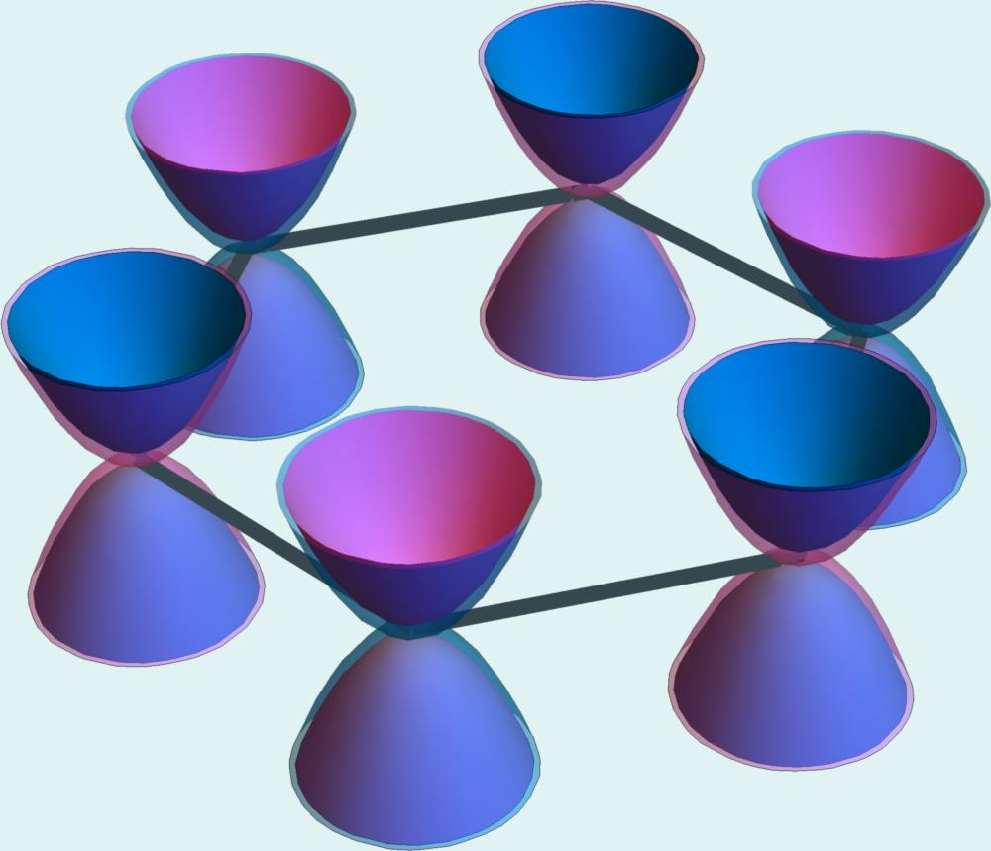
Formed by joining hollow cones or arranging conical components around an empty internal region.
Types include:
- Coaxial Hollow Cone Arrangement.
- Nested Hollow Cone Arrangement.
- Stacked Hollow Cone Arrangement.
- Opposing Hollow Cone Arrangement.
- Multi-Layer Hollow Cone Arrangement.
- Repeated Conical Shell Arrangement.

Symmetrical Cone-Based Composite Solids
# Source: AI Source: Provided by: [Data Path: Persons Table -> ID Column: 1, Name_En Column: Motasem Essam] -> From: [ChatGPT] on [7/25/2026]
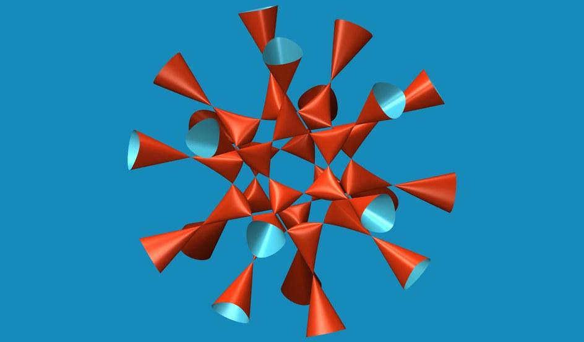
Formed by arranging cones so that the overall structure has one or more symmetry properties.
Types include:
- Axially Symmetrical Arrangement.
- Rotationally Symmetrical Arrangement.
- Reflection-Symmetrical Arrangement.
- Radially Symmetrical Arrangement.
- Centrally Balanced Arrangement.

Irregular Cone-Based Composite Solids
# Source: AI Source: Provided by: [Data Path: Persons Table -> ID Column: 1, Name_En Column: Motasem Essam] -> From: [ChatGPT] on [7/25/2026]
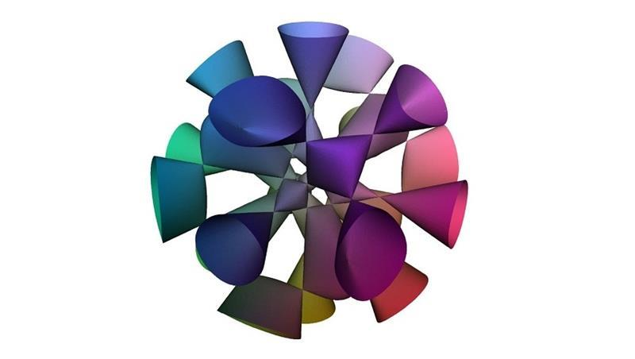
Formed by combining cones in a non-uniform arrangement without a regular overall pattern.
Types include:
- Random Cone Arrangement.
- Uneven Multi-Level Arrangement.
- Asymmetrical Arrangement.
- Mixed-Dimension Arrangement.
- Different-Orientation Arrangement.
- Complex Intersecting Arrangement.

Classification by Cone Arrangement
# Source: AI Source: Provided by: [Data Path: Persons Table -> ID Column: 1, Name_En Column: Motasem Essam] -> From: [ChatGPT] on [7/25/2026]
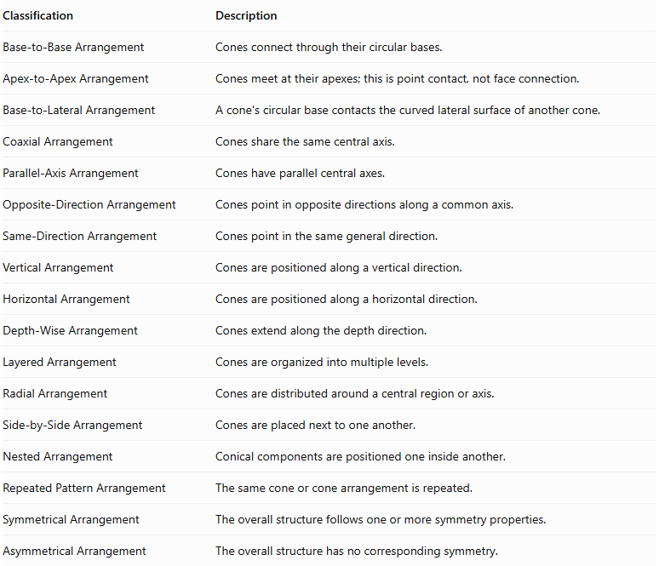
Classification | Description
Base-to-Base Arrangement | Cones connect through their circular bases.
Apex-to-Apex Arrangement | Cones meet at their apexes; this is point contact, not face connection.
Base-to-Lateral Arrangement | A cone's circular base contacts the curved lateral surface of another cone.
Coaxial Arrangement | Cones share the same central axis.
Parallel-Axis Arrangement | Cones have parallel central axes.
Opposite-Direction Arrangement | Cones point in opposite directions along a common axis.
Same-Direction Arrangement | Cones point in the same general direction.
Vertical Arrangement | Cones are positioned along a vertical direction.
Horizontal Arrangement | Cones are positioned along a horizontal direction.
Depth-Wise Arrangement | Cones extend along the depth direction.
Layered Arrangement | Cones are organized into multiple levels.
Radial Arrangement | Cones are distributed around a central region or axis.
Side-by-Side Arrangement | Cones are placed next to one another.
Nested Arrangement | Conical components are positioned one inside another.
Repeated Pattern Arrangement | The same cone or cone arrangement is repeated.
Symmetrical Arrangement | The overall structure follows one or more symmetry properties.
Asymmetrical Arrangement | The overall structure has no corresponding symmetry.

Classification by Number and Dimensions of Cones
# Source: AI Source: Provided by: [Data Path: Persons Table -> ID Column: 1, Name_En Column: Motasem Essam] -> From: [ChatGPT] on [7/25/2026]
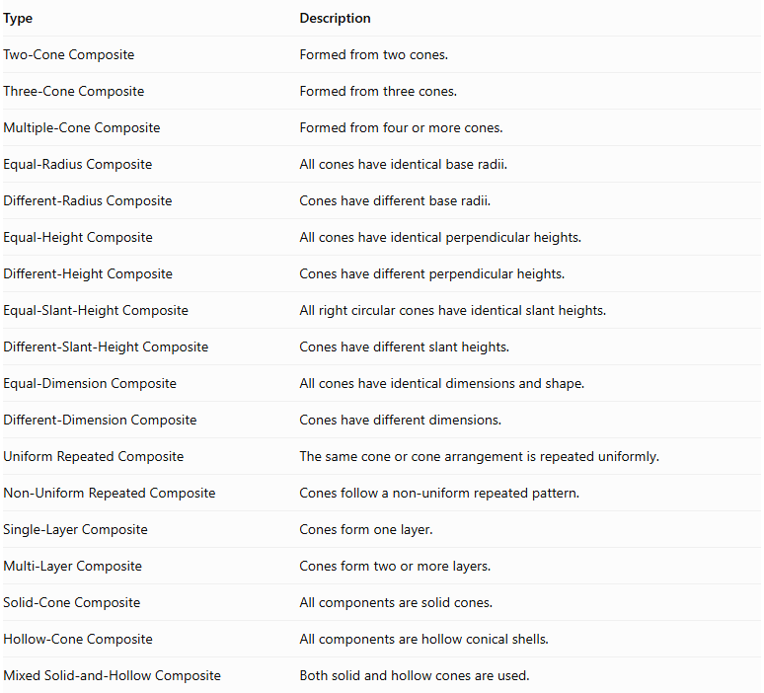
Type | Description
Two-Cone Composite | Formed from two cones.
Three-Cone Composite | Formed from three cones.
Multiple-Cone Composite | Formed from four or more cones.
Equal-Radius Composite | All cones have identical base radii.
Different-Radius Composite | Cones have different base radii.
Equal-Height Composite | All cones have identical perpendicular heights.
Different-Height Composite | Cones have different perpendicular heights.
Equal-Slant-Height Composite | All right circular cones have identical slant heights.
Different-Slant-Height Composite | Cones have different slant heights.
Equal-Dimension Composite | All cones have identical dimensions and shape.
Different-Dimension Composite | Cones have different dimensions.
Uniform Repeated Composite | The same cone or cone arrangement is repeated uniformly.
Non-Uniform Repeated Composite | Cones follow a non-uniform repeated pattern.
Single-Layer Composite | Cones form one layer.
Multi-Layer Composite | Cones form two or more layers.
Solid-Cone Composite | All components are solid cones.
Hollow-Cone Composite | All components are hollow conical shells.
Mixed Solid-and-Hollow Composite | Both solid and hollow cones are used.

Mathematical Properties and Formulas

Volume of One Cone
# Source: AI Source: Provided by: [Data Path: Persons Table -> ID Column: 1, Name_En Column: Motasem Essam] -> From: [ChatGPT] on [7/25/2026]
The volume of a cone is:
$$\boxed{V_{cone}=\frac{1}{3}πr^{2}h}$$
Where:
- $r$ = radius of the circular base.
- $h$ = perpendicular height from the apex to the base plane.

Total Volume of Equal Cones
# Source: AI Source: Provided by: [Data Path: Persons Table -> ID Column: 1, Name_En Column: Motasem Essam] -> From: [ChatGPT] on [7/25/2026]
For $n$ identical cones:
$$\boxed{V_{total}=\frac{n}{3}πr^{2}h}$$
Where:
- $n$ = number of cones.
- $r$ = base radius of each cone.
- $h$ = perpendicular height of each cone.

Total Volume of Different Cones
# Source: AI Source: Provided by: [Data Path: Persons Table -> ID Column: 1, Name_En Column: Motasem Essam] -> From: [ChatGPT] on [7/25/2026]
When the cones have different dimensions:
$$\boxed{V_{total}=\sum_{i=1}^{n}{\frac{1}{3}}πr_{i}^{2}h_{i}}$$
This formula assumes that the cone interiors do not overlap. If components intersect, the overlapping volume must be counted only once.

Slant Height of a Right Circular Cone
# Source: AI Source: Provided by: [Data Path: Persons Table -> ID Column: 1, Name_En Column: Motasem Essam] -> From: [ChatGPT] on [7/25/2026]
For a right circular cone:
$$\boxed{l=\sqrt{r^{2}+h^{2}}}$$
Where:
- $l$ = slant height.
- $r$ = base radius.
- $h$ = perpendicular height.
This relationship does not generally apply to oblique cones.

Surface Area of One Right Circular Cone
# Source: AI Source: Provided by: [Data Path: Persons Table -> ID Column: 1, Name_En Column: Motasem Essam] -> From: [ChatGPT] on [7/25/2026]
Curved surface area:
$$CSA=πrl$$
Base area:
$$A_{base}=πr^{2}$$
Total surface area:
$$\boxed{SA=πr^{2}+πrl}$$

Surface Area of Repeated Cones
# Source: AI Source: Provided by: [Data Path: Persons Table -> ID Column: 1, Name_En Column: Motasem Essam] -> From: [ChatGPT] on [7/25/2026]
For $n$ separate identical right circular cones:
$${SA}_{separate}=n(πr^{2}+πrl)$$
When cones are connected through complete matching circular bases, the joining bases become hidden.
For $m$ complete base-to-base connections:
$$\boxed{{SA}_{total}=n(πr^{2}+πrl)-2mπr^{2}}$$
This formula assumes equal base radii and complete circular-face connections.
For different cone dimensions, use the general principle:
$${SA}_{total}=\sum{{SA}_{i}}-2\sum{A_{shared}}$$
This applies to complete planar interfaces. Partial or curved contact requires calculating the actual hidden surface regions.

Special Formula for Equal Cones Joined Base-to-Base
# Source: AI Source: Provided by: [Data Path: Persons Table -> ID Column: 1, Name_En Column: Motasem Essam] -> From: [ChatGPT] on [7/25/2026]
For two identical right circular cones joined through their complete circular bases:
Total volume:
$$\boxed{V_{total}=\frac{2}{3}πr^{2}h}$$
External surface area:
$$\boxed{{SA}_{total}=2πrl}$$
The two circular bases are hidden inside the composite structure, so only the two curved lateral surfaces remain exposed.

Hollow Cone Formulas
# Source: AI Source: Provided by: [Data Path: Persons Table -> ID Column: 1, Name_En Column: Motasem Essam] -> From: [ChatGPT] on [7/25/2026]
For a hollow conical frustum with outer radius $R$, inner radius $r$, perpendicular height $h$, and corresponding slant heights $L$ and $l$:
$$V=\frac{1}{3}πh(R^{2}+Rr+r^{2})$$
For a hollow conical shell with an outer and inner conical surface sharing the same apex and height, its material volume is the difference between the outer and inner cone volumes:
$$\boxed{V_{shell}=\frac{1}{3}πh(R^{2}-r^{2})}$$
The surface area of a hollow conical structure depends on whether its circular ends are open, closed, or connected to other components.

Worked Examples

Example 1: Equal Cones Joined Base-to-Base
# Source: AI Source: Provided by: [Data Path: Persons Table -> ID Column: 1, Name_En Column: Motasem Essam] -> From: [ChatGPT] on [7/25/2026]
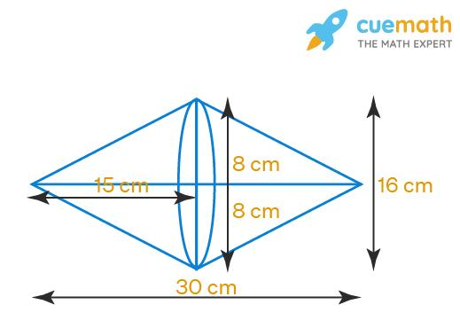
Given:
- Number of cones: $n=2$.
- Base radius of each cone: $r=3 cm$.
- Perpendicular height of each cone: $h=4 cm$.
- Arrangement: base-to-base.
Step 1: Calculate the slant height of each cone.
$$l=\sqrt{r^{2}+h^{2}}$$
$$l=\sqrt{3^{2}+4^{2}}$$
$$l=\sqrt{9+16}=5 cm$$
Step 2: Calculate the volume of one cone.
$$V_{1}=\frac{1}{3}πr^{2}h$$
$$V_{1}=\frac{1}{3}π(3)^{2}(4)$$
$$V_{1}=12π$$
Step 3: Calculate the total volume.
$$V_{total}=2(12π)$$
$$\boxed{V_{total}=24π≈75.40{ cm}^{3}}$$
<badge color="success">Volume = 75.40 cm³</badge>
Step 4: Calculate the curved surface area of one cone.
$${CSA}_{1}=πrl$$
$${CSA}_{1}=π(3)(5)=15π$$
Step 5: Calculate the external surface area.
Both circular bases are hidden at the joining interface.
$${SA}_{total}=2(15π)$$
$$\boxed{{SA}_{total}=30π≈94.25{ cm}^{2}}$$
<badge color="success">Surface Area = 94.25 cm²</badge>
Final Result:
- Total Volume = $24π≈75.40{ cm}^{3}$.
- External Surface Area = $30π≈94.25{ cm}^{2}$.

Example 2: Different-Radius Coaxial Cones Joined Base-to-Base
# Source: AI Source: Provided by: [Data Path: Persons Table -> ID Column: 1, Name_En Column: Motasem Essam] -> From: [ChatGPT] on [7/25/2026]
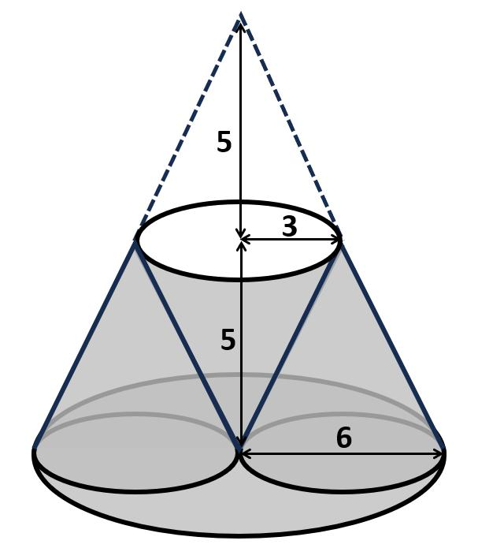
Given:
- Lower cone:
- Base radius: $R=4 cm$.
- Perpendicular height: $h_{1}=3 cm$.
- Upper cone:
- Base radius: $r=2 cm$.
- Perpendicular height: $h_{2}=3 cm$.
- Arrangement: coaxial, with the smaller circular base joined to the central region of the larger circular base.
Step 1: Calculate the slant height of the lower cone.
$$l_{1}=\sqrt{R^{2}+h_{1}^{2}}$$
$$l_{1}=\sqrt{4^{2}+3^{2}}=5 cm$$
Step 2: Calculate the slant height of the upper cone.
$$l_{2}=\sqrt{r^{2}+h_{2}^{2}}$$
$$l_{2}=\sqrt{2^{2}+3^{2}}$$
$$l_{2}=\sqrt{13} cm$$
Step 3: Calculate the volume of the lower cone.
$$V_{1}=\frac{1}{3}πR^{2}h_{1}$$
$$V_{1}=\frac{1}{3}π(4)^{2}(3)=16π$$
Step 4: Calculate the volume of the upper cone.
$$V_{2}=\frac{1}{3}πr^{2}h_{2}$$
$$V_{2}=\frac{1}{3}π(2)^{2}(3)=4π$$
Step 5: Calculate the total volume.
$$V_{total}=16π+4π$$
$$\boxed{V_{total}=20π≈62.83{ cm}^{3}}$$
<badge color="success">Volume = 62.83 cm³</badge>
Step 6: Calculate the curved surface area of both cones.
Lower cone:
$${CSA}_{1}=π{Rl}_{1}$$
$${CSA}_{1}=π(4)(5)=20π$$
Upper cone:
$${CSA}_{2}=π{rl}_{2}$$
$${CSA}_{2}=2π\sqrt{13}$$
Step 7: Calculate the exposed annular base of the lower cone.
The smaller cone hides a circular region of radius $2 cm$ on the larger cone's base.
$$A_{annulus}=π(R^{2}-r^{2})$$
$$A_{annulus}=π(16-4)=12π$$
Step 8: Calculate the total external surface area.
The upper cone's base is hidden, and the lower cone's base remains exposed as an annulus.
$${SA}_{total}={CSA}_{1}+{CSA}_{2}+A_{annulus}$$
$$=20π+2π\sqrt{13}+12π$$
$$\boxed{{SA}_{total}=32π+2π\sqrt{13}}$$
$${SA}_{total}≈123.65{ cm}^{2}$$
<badge color="success">Surface Area = 123.65 cm²</badge>
Final Result:
- Total Volume = $20π≈62.83{ cm}^{3}$.
- External Surface Area = $32π+2π\sqrt{13}≈123.65{ cm}^{2}$.

Important Characteristics
# Source: AI Source: Provided by: [Data Path: Persons Table -> ID Column: 1, Name_En Column: Motasem Essam] -> From: [ChatGPT] on [7/25/2026]
- Repeated Components: The structure contains multiple cone components.
- Variable Dimensions: Cones may have equal or different base radii, heights, and slant heights.
- Circular Joining Faces: Cones commonly connect through their circular bases.
- Curved External Surfaces: The outer boundary includes conical lateral surfaces.
- Apex Orientation: Cones can point in the same or opposite directions.
- Flexible Configurations: They can form stacked, coaxial, radial, and irregular structures.
- Hidden Surfaces: Joining regions are excluded from the external surface area.
- Additive Volume: Component volumes can be added when their interiors do not overlap.
- Symmetry Properties: The overall structure may have rotational, axial, or reflection symmetry.
- Modular Construction: Additional cones can extend an existing arrangement.

Comparison with Other Repeated Composite Solids
# Source: AI Source: Provided by: [Data Path: Persons Table -> ID Column: 1, Name_En Column: Motasem Essam] -> From: [ChatGPT] on [7/25/2026]
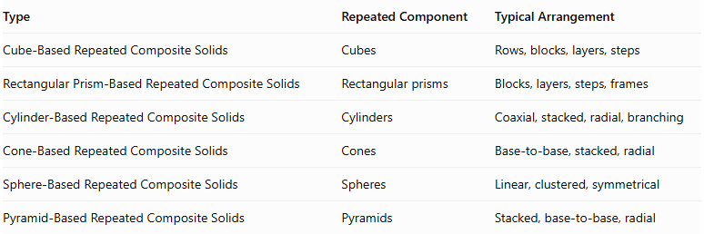
Type | Repeated Component | Typical Arrangement
Cube-Based Repeated Composite Solids | Cubes | Rows, blocks, layers, steps
Rectangular Prism-Based Repeated Composite Solids | Rectangular prisms | Blocks, layers, steps, frames
Cylinder-Based Repeated Composite Solids | Cylinders | Coaxial, stacked, radial, branching
Cone-Based Repeated Composite Solids | Cones | Base-to-base, stacked, radial
Sphere-Based Repeated Composite Solids | Spheres | Linear, clustered, symmetrical
Pyramid-Based Repeated Composite Solids | Pyramids | Stacked, base-to-base, radial
Main distinction: Cone-based repeated composite solids use cones as their repeated building components. Their geometry is characterized by circular bases, apexes, perpendicular heights, slant heights, and curved lateral surfaces.

Applications
# Source: AI Source: Provided by: [Data Path: Persons Table -> ID Column: 1, Name_En Column: Motasem Essam] -> From: [ChatGPT] on [7/25/2026]
- Architecture: Designing conical roofs, decorative structures, and repeated pointed elements.
- Mechanical Engineering: Developing conical components and specialized assemblies.
- Manufacturing: Producing funnels, nozzles, and conical mechanical parts.
- Industrial Design: Creating repeated conical products and decorative objects.
- Construction: Designing conical supports and structural elements.
- Mathematics Education: Teaching cone volume, surface area, and spatial arrangements.
- Computer Graphics: Constructing three-dimensional models using repeated cones.
- Game Design: Creating towers, pointed structures, and decorative environments.
- Packaging Design: Developing conical containers and repeated funnel-shaped structures.
- Product Design: Designing arrangements of conical components.

Key Points
# Source: AI Source: Provided by: [Data Path: Persons Table -> ID Column: 1, Name_En Column: Motasem Essam] -> From: [ChatGPT] on [7/25/2026]
- Cone-based repeated composite solids consist of multiple cones joined into a structure.
- Their components may have equal or different radii, heights, and slant heights.
- They can form linear, coaxial, base-to-base, stacked, radial, and irregular arrangements.
- The volume of one cone is:
$$V=\frac{1}{3}πr^{2}h$$
- For $n$ identical non-overlapping cones:
$$V_{total}=\frac{n}{3}πr^{2}h$$
- The curved surface area of a right circular cone is:
$$CSA=πrl$$
- The total surface area of a right circular cone is:
$$SA=πr^{2}+πrl$$
- Shared circular bases must be excluded from the external surface area.
- Apex-to-apex contact is point contact, not a complete joining face.
- Different-radius cones may create partially exposed annular base regions.

Conclusion
# Source: AI Source: Provided by: [Data Path: Persons Table -> ID Column: 1, Name_En Column: Motasem Essam] -> From: [ChatGPT] on [7/25/2026]
Cone-Based Repeated Composite Solids are three-dimensional structures formed by joining multiple cones in repeated arrangements. They include linear structures, coaxial arrangements, double cones, stacked cones, radial configurations, hollow structures, and irregular assemblies.
Their mathematical properties are based on cone volume, circular base areas, slant heights, curved lateral surfaces, and the relationships between their apexes and central axes.
They provide a foundation for understanding more complex repeated composite solids and conical structures used in engineering, architecture, manufacturing, and geometric modeling.

